**TASK-2**

**Q1: Python program to print all the even number within a given range**

**PROGRAM**

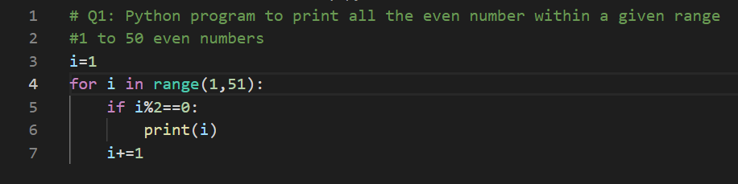

**OUTPUT**

**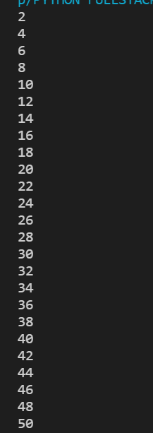  
  
Q2: Python program to calculate the sum of the odd numbers within the given range  
PROGRAM**

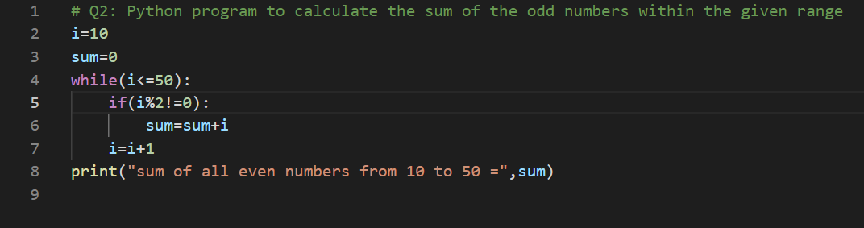

**OUTPUT  
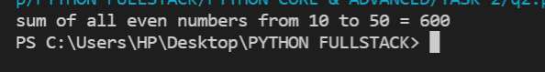**

**Q3: Python program to check if the given string is a palindrome or not  
->Palindrome-a word that reads the same backward as forward  
Madam=madaM  
PROGRAM**

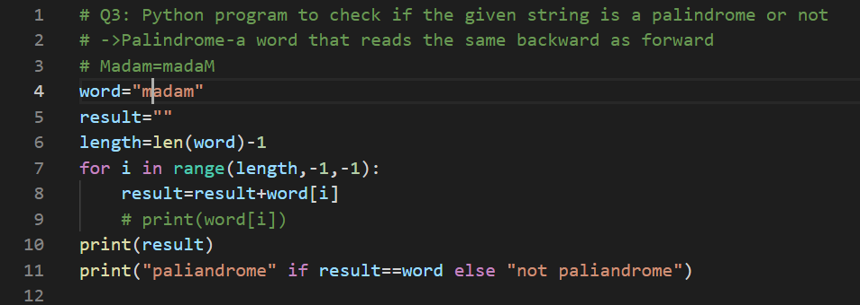

**OUTPUT**

**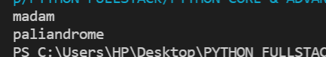  
Q4: Python program to check if a given number is an Armstrong  
number    
->An Armstrong number is a number that equals to the sum of its individual,  
digits each raised to the power of the number of digits  
eg:-153  
 number of digits  = 3  
1^3+5^3+3^3=1+125+27=153**

**PROGRAM**

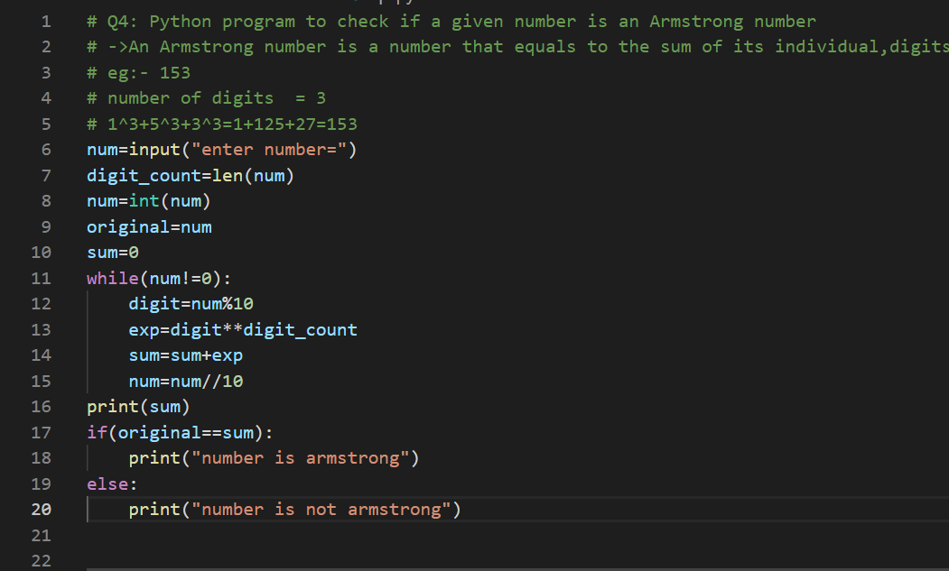

**OUTPUT  
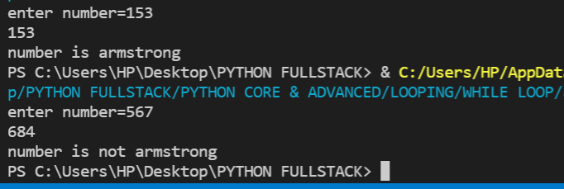**

**Q5: Python program to get the Fibonacci series between 0 to 50  
PROGRAM**

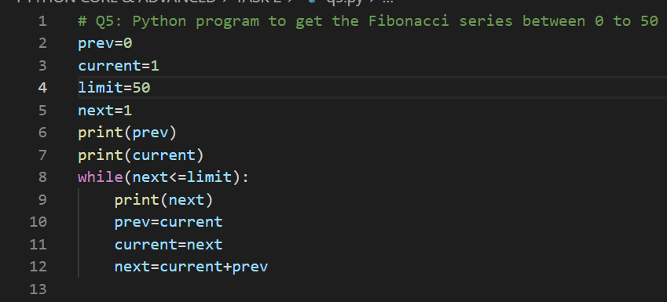

**OUTPUT  
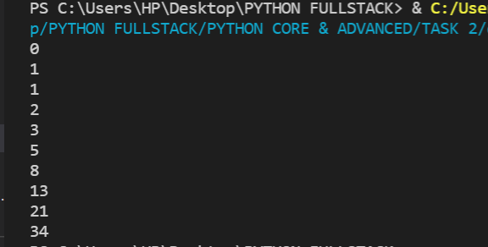  
Q6: Python program to check given number is prime or not**

**PROGRAM**

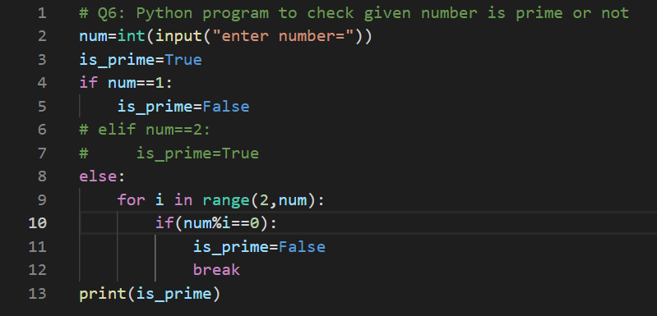

**OUTPUT**

